Ref. No: Date: 04/09/2023.

Notice Regarding 2nd Semester GE Practical exam
It is hereby notify to all students of 2nd semester GE that practical exam on CHEMGP - 2 will be held on 19/9/2023. All students must come at 10:30 am at departmental practical room with their own admit card, Lab-coat, Practical Notebook, spatula, dropper etc. No excuse will be entertained.

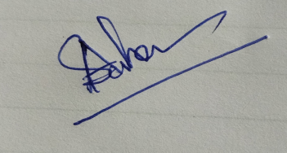
HOD
Department of Chemistry

